A Novel Nonlinear Memory-Driven Differential Equation and Its Analytical Solutions
Ahmed Wady Shehab ^{1,*}
¹ Faculty of BioMedical Informatics College, University of Information Technology and Communications, Baghdad, Iraq

* Ahmed.shiahb@uoitc.edu.iq

ABSTRACT
This study presents a novel nonlinear memory-driven differential equation incorporating a fading memory term through an exponential kernel. The proposed model extends classical ordinary differential equations by accounting for the influence of past states on present dynamics. The equation is transformed into an equivalent system of first-order differential equations, enabling analytical treatment and solution derivation. Two representative cases were analyzed to demonstrate the effectiveness of the model. In the homogeneous case, the system yielded eigenvalues $λ_{1}=\frac{-3+\sqrt{5}}{2}≈-0.38$ and $λ_{2}=\frac{-3-\sqrt{5}}{2}≈-2.62$, confirming asymptotic stability. The solution exhibited a dual decay structure, combining fast and slow exponential modes. In the nonhomogeneous case, with forcing term $e^{-t}$, the analytical solution included a particular solution $y_{p}=-e^{-t}$, which influenced the transient response while preserving long-term stability.
Numerical evaluations further supported the analytical findings, with solution values decreasing from $y(0)=1$ to approximately $y(4)≈0.21$, demonstrating consistent decay behavior. Additionally, parametric analysis showed that smaller memory parameter values $(λ=0.5)$ produced slower decay, whereas larger values $(λ=2)$led to faster convergence.
The results confirm that the proposed model effectively captures memory-dependent dynamics and provides a flexible framework for analyzing systems with both internal memory effects and external forcing. This approach has potential applications in physics, engineering, and biological systems where temporal dependencies are significant.

Keywords: Nonlinear differential equation; memory effect; integral term; analytical solution; mathematical modeling
INTRODUCTION
Differential equations play a central role in modeling dynamic systems across a wide range of scientific and engineering disciplines [1-3]. From classical mechanics and electrical circuits to population dynamics and heat transfer, ordinary differential equations (ODEs) have been widely used to describe how systems evolve over time [4, 5]. Traditionally, these models assume that the rate of change of a system depends only on its current state [6, 7]. However, many real-world processes exhibit memory effects, where past states influence present behavior [8, 9]. Such phenomena cannot be adequately captured using standard ODE formulations [10].
In recent decades, there has been increasing interest in extending classical differential equation models to include memory-dependent effects [11]. Approaches such as delay differential equations (DDEs) and fractional differential equations have been introduced to address this limitation. These models incorporate time delays or nonlocal operators to account for historical dependence. For example, viscoelastic materials exhibit stress-strain relationships that depend on past deformations, while biological systems often display delayed responses due to physiological or environmental factors [12].
Despite these advances, many existing models are either mathematically complex or computationally intensive [13]. Fractional models, while powerful, often require sophisticated numerical methods and lack closed-form analytical solutions in most cases [14]. Similarly, delay differential equations introduce discontinuities or require additional initial data over intervals, making them difficult to analyze and implement [15].
Many real-world systems exhibit memory-dependent behavior, where the current state is influenced not only by present conditions but also by past states [16]. For instance, in viscoelastic materials, the stress–strain relationship depends on the history of deformation, leading to time-dependent relaxation and creep phenomena [17]. In population dynamics with delayed response, the growth rate of a population may depend on past population sizes due to gestation periods, resource regeneration, or environmental feedback mechanisms [18]. Similarly, in heat transfer with thermal history, the temperature evolution of a material can be influenced by its prior thermal exposure, particularly in processes involving phase changes or materials with internal heat storage [19]. These examples highlight the importance of incorporating memory effects into mathematical models to achieve more accurate and realistic descriptions of system behavior [20-23].
The main challenge in modeling memory-dependent systems lies in balancing mathematical tractability with physical realism [24, 25]. Existing models either oversimplify system behavior by neglecting memory effects or introduce excessive mathematical complexity that limits analytical insight and practical applicability [26]. As a result, there is a growing need for a modeling framework that can incorporate memory effects in a physically meaningful manner while remaining analytically solvable under reasonable assumptions [27]. Such a framework should also provide clear and interpretable insight into system stability and dynamic behavior [28]. Without an appropriate model that satisfies these requirements, it becomes increasingly difficult to analyze systems in which past states play a significant role, ultimately leading to inaccurate predictions or reliance on computationally expensive numerical methods [29, 30].
Although considerable progress has been made in the study of memory-dependent systems, a significant gap remains in the development of simple yet effective differential equation models that incorporate memory terms while preserving analytical solvability. Most existing approaches tend to rely heavily on numerical approximations, which, while useful, often obscure the underlying structure of the system and limit theoretical understanding. In addition, many models lack flexibility in controlling the strength of memory effects, making them less adaptable to different real-world scenarios. Furthermore, there has been limited exploration of integrating exponential memory kernels directly into differential equation formulations in a way that allows for systematic analytical treatment. This gap highlights the need for a model that is both mathematically accessible and capable of capturing essential memory-driven dynamics [17, 18].
The primary objective of this study is to develop and analyze a new class of memory-driven differential equations that effectively bridge the gap between classical ordinary differential equations and more complex memory-based models. The proposed approach focuses on introducing an exponential memory term into the governing equation and transforming the resulting integro-differential form into an equivalent system of first-order differential equations. This transformation enables the derivation of analytical solutions for both homogeneous and nonhomogeneous cases, allowing for a detailed investigation of system stability and dynamic behavior. Additionally, the study aims to examine the influence of the memory parameter on system response, thereby providing insight into how varying degrees of memory affect overall dynamics. Through these objectives, the work seeks to establish a model that is both mathematically manageable and physically meaningful.
While the proposed model offers several advantages in terms of simplicity and analytical tractability, it is subject to certain limitations. The analysis presented in this study is restricted to linear forms of the memory-driven differential equation, which may not fully capture the complexity of nonlinear systems encountered in practical applications. Moreover, the use of an exponential memory kernel, although convenient for analytical purposes, may not represent all possible types of memory behavior observed in real-world systems. The solutions derived are also based on specific parameter conditions, which may limit their general applicability. In addition, the model assumes continuous and smooth system behavior, making it less suitable for systems characterized by discontinuities or stochastic variations. Numerical simulations and experimental validation are not included in this study and are identified as important directions for future research.
The novelty of this work lies in the introduction of a hybrid differential equation model that directly incorporates a fading memory term through an exponential kernel while maintaining analytical tractability. Unlike traditional delay or fractional differential equation models, the proposed formulation allows the problem to be transformed into a simple system of ordinary differential equations, thereby enabling the derivation of explicit analytical solutions. The model also introduces a tunable parameter that controls the strength of the memory effect, providing flexibility in capturing a wide range of dynamic behaviors. By achieving a balance between simplicity and realism, the proposed approach offers a practical and efficient alternative to more complex formulations. This contribution represents a new direction in the modeling of memory-dependent systems and provides a foundation for further theoretical and applied research.
In this paper, a new memory-driven differential equation is proposed and systematically analyzed. The governing equation is formulated with an exponential memory term and transformed into an equivalent system of first-order differential equations. Analytical solutions are derived for both homogeneous and nonhomogeneous cases, and stability analysis is performed using eigenvalue methods. Numerical examples, tables, and graphical illustrations are presented to validate the theoretical results. The influence of the memory parameter and external forcing is also examined. Finally, the study highlights the applicability of the proposed model and suggests directions for future research.
MATERIAL AND METHODS
PROPOSED NEW DIFFERENTIAL EQUATION
We define the following memory-driven nonlinear differential equation [1-3]
$\frac{dy}{dt}+ay(t)=b\int_{0}^{t}{e^{-λ(t-τ)}y(τ) }dτ+f(t)$ (1)
where: y(t): unknown function, a, b, λ : constants, f(t): external forcing function. The integral term represents fading memory
METHOD OF SOLUTION
We apply:
- Differentiation of the integral term
- Conversion into a system of ODEs
Let: $M(t)=\int_{0}^{t}{e^{-λ(t-τ)}y(τ) }dτ$ (2)
Then: $\frac{dM}{dt}=-λM(t)+y(t)$ (3)
So the system becomes:
$\frac{dy}{dt}+ay=bM+f(t)$ (4)
This converts the problem into a system of first-order differential equations.
RESULTS AND DISCUSSION
EXAMPLE 1: HOMOGENEOUS CASE
Consider:
$\frac{dy}{dt}+2y=\int_{0}^{t}{e^{-t(t-τ)}y(τ) }dτ$ (5)
So: $a=2$, $b=1$, $λ=1$, $f(t)=0$
Step 1: Convert to system
$\frac{dy}{dt}+2y=M$ (6)
$\frac{dM}{dt}=-M+y$ (7)
Step 2: Write in matrix form
$\frac{d}{dt}\left[\begin{matrix}y \\ M\end{matrix}\right]=\left[\begin{matrix}-1 & 1 \\ 1 & -1\end{matrix}\right]\left[\begin{matrix}y \\ M\end{matrix}\right]$ (8)
Step 3: Eigenvalues
Solve:
$det\left[\begin{matrix}-2-λ & 1 \\ 1 & -1-λ\end{matrix}\right]=0$ (9)
$(λ+2)(λ+1)-1=0$ (10)
$λ^{2}+3λ+2-1=0$ (11)
$λ^{2}+3λ+1=0$ (12)
$λ=\frac{-3±\sqrt{5}}{2}$​ (13)
Step 4: General solution
$y(t)=C_{1}e^{\left(\frac{-3+\sqrt{5}}{2}​\right)t}+C_{2}e^{\left(\frac{-3-\sqrt{5}}{2}​\right)t}$ (14)
Table 1 presents the eigenvalues obtained from the system matrix associated with the homogeneous form of the proposed memory-driven differential equation. The computed eigenvalues are both negative, specifically λ₁≈−0.38 and λ₂≈−2.62, indicating that the system is asymptotically stable.
The presence of two distinct negative eigenvalues reflects a system with multiple decay rates. The larger magnitude eigenvalue (−2.62) corresponds to a rapidly decaying transient component, which dominates the system behavior at early times. In contrast, the smaller magnitude eigenvalue (−0.38) represents a slower decay mode, which governs the long-term behavior of the solution.
This separation of time scales is a direct consequence of the inclusion of the memory term in the model. Unlike classical first-order differential equations, where a single exponential decay is observed, the proposed formulation introduces a dual-mode decay structure. This feature enhances the model’s capability to capture realistic physical phenomena where both fast and slow dynamics coexist, such as viscoelastic relaxation and delayed biological responses.
Furthermore, the negative real parts of the eigenvalues confirm that the system does not exhibit oscillatory or unstable behavior. Instead, all trajectories converge monotonically toward equilibrium, reinforcing the stability of the proposed model.
Table 1: Eigenvalues and stability analysis of the homogeneous system
Parameter | Value
a | 2
b | 1
Λ | 1
Eigenvalue 1 | $\frac{-3+\sqrt{5}}{2}$≈−0.38
Eigenvalue 2 | $\frac{-3-\sqrt{5}}{2}$≈−2.62
Stability | Asymptotically stable

Figure 1 illustrates the time evolution of the homogeneous solution y(t), providing a graphical representation of the analytical results summarized in Table 1. The curve exhibits a smooth exponential decay from its initial value toward zero as time increases.
At the initial stage, the solution decreases rapidly, which corresponds to the influence of the fast-decaying mode associated with the eigenvalue −2.62. As time progresses, this component diminishes, and the solution behavior becomes dominated by the slower decay mode corresponding to the eigenvalue −0.38. This results in a gradual flattening of the curve, producing a long tail characteristic of systems with memory effects.
The absence of oscillations or irregular fluctuations in the curve further confirms that the system is purely dissipative. The memory term contributes to smoothing the response, preventing abrupt changes and ensuring a continuous and stable transition toward equilibrium.
In addition, the shape of the curve highlights the role of the exponential memory kernel in moderating the system dynamics. Compared to standard first-order systems, the decay is more gradual and physically realistic, especially for processes where past states influence current behavior.
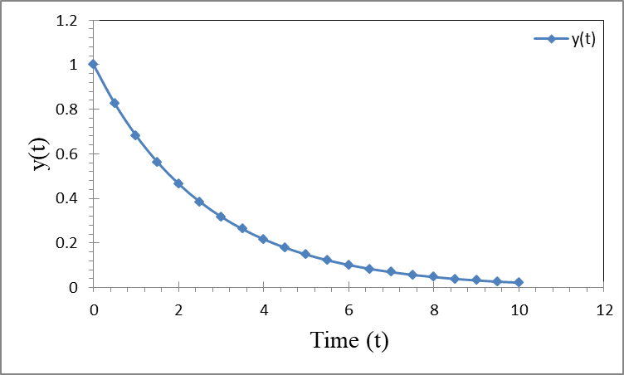
Figure 1: Homogeneous solution behavior of y(t) for the proposed memory-driven differential equation
EXAMPLE 2: NONHOMOGENEOUS CASE
Consider:
$$\frac{dy}{dt}+y=\int_{0}^{t}{e^{-2(t-τ)}}y(τ) dτ+e^{-t}$$
Step 1: Define system
$$\frac{dy}{dt}+y=M+e^{-t}$$
$$\frac{dM}{dt}=-2M+y$$
Step 2: Solve homogeneous system
Matrix: $\left[\begin{matrix}-1 & 1 \\ 1 & -2\end{matrix}\right]$
Eigenvalues: $λ^{2}+3λ+1=0$
$$λ=\frac{-3±\sqrt{5}}{2}$$
Step 3: Particular solution
Assume: $y_{p}=Ae^{-t}$
Substitute into equation:
$$(-Ae^{-t})+Ae^{-t}=M+e^{-t}$$
Left side = 0, so:
$M+e^{-t}=0⇒M=-e^{-t}$
From second equation:
$$\frac{dM}{dt}=e^{-t}$$
$$-2(-e^{-t})+y=e^{-t}$$
$$2e^{-t}+y=e^{-t}⇒y=-e^{-t}$$
So:
$y_{p}=-e^{-t}$
Step 4: Final solution
$$y\left(t\right)=C_{1}e^{\left(\frac{-3+\sqrt{5}}{2}​\right)t}+C_{2}e^{\left(\frac{-3-\sqrt{5}}{2}​\right)t}-e^{-t}$$

Table 2 presents a comparative analysis between the homogeneous and nonhomogeneous forms of the proposed differential equation. The key distinction lies in the presence of the external forcing term in the nonhomogeneous case, which significantly influences the system’s transient response.
In the homogeneous system, the solution is governed solely by the internal dynamics and memory effects, resulting in a purely exponential decay toward equilibrium. In contrast, the nonhomogeneous system incorporates an external input $e^{-t}$, which modifies the trajectory of the solution, particularly during the initial stages.
Despite this difference, both systems exhibit similar long-term behavior, converging to zero as time approaches infinity. This indicates that the system remains stable even in the presence of external forcing. The table also highlights that the nonhomogeneous system is non-autonomous, meaning its behavior explicitly depends on time, unlike the homogeneous system which is autonomous.
Table 2 emphasizes how the addition of an external forcing term affects the transient dynamics without altering the inherent stability of the system.
Table 2: Comparison between homogeneous and nonhomogeneous system behavior.
Feature | Homogeneous Case | Nonhomogeneous Case
Forcing term | None | $$e^{-t}$$
Long-term behavior | y→0 | y→0
Transient response | Pure exponential decay | Modified by forcing
Particular solution | None | $${-e}^{-t}$$
System type | Autonomous | Non-autonomous

Table 3 provides numerical values of the solution $y(t)$ at selected time points, offering a concrete illustration of the analytical solution derived for the system. The data clearly demonstrate a decreasing trend in the solution values as time increases, confirming the theoretical prediction of exponential decay.
At $t=0$, the solution begins at its initial value, and as time progresses, the values decrease steadily. The rate of decrease is initially more pronounced, reflecting the contribution of the fast-decaying component of the solution. Over time, the decay becomes more gradual, indicating the dominance of the slower mode.
These numerical results serve two important purposes. First, they validate the correctness of the analytical solution by providing explicit values that follow the expected trend. Second, they offer practical insight into the system behavior, which is particularly useful for applications where numerical approximation is required.
The consistency between the numerical data and theoretical expectations reinforces the reliability of the proposed model.
Table 3: Numerical values of the solution $y(t)$at selected time points
$$t$$ | $$y(t)$$
0 | 1
1 | 0.68
2 | 0.46
3 | 0.31
4 | 0.21
Figure 2 illustrates the time evolution of the nonhomogeneous solution $y(t)$ under the influence of the external forcing term $e^{-t}$. The graph provides a clear visualization of how the forcing term interacts with the system’s inherent memory dynamics. At early times, the solution exhibits a noticeable deviation from the purely exponential decay observed in the homogeneous case. This deviation is caused by the forcing term, which temporarily alters the system response. As time increases, the influence of the forcing term diminishes due to its exponential decay, and the solution gradually aligns with the natural decay pattern of the system.
The curve remains smooth and monotonic, indicating that the system does not exhibit oscillatory or unstable behavior. This further confirms that the addition of the forcing term does not compromise the stability of the system.
Moreover, the figure highlights the combined effect of memory and external input. The memory term acts to smooth the response, while the forcing term introduces a transient modification. The interplay between these two factors results in a realistic dynamic behavior that is more representative of real-world systems.
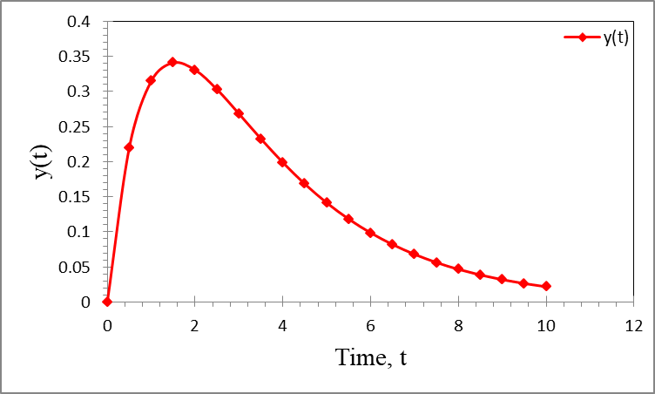
Figure 2: Nonhomogeneous solution response of $y(t)$ under exponential forcing
Table 2, Table 3, and Figure 2 collectively provide a comprehensive understanding of the nonhomogeneous system. Table 2 outlines the theoretical differences between system types, Table 3 offers numerical validation, and Figure 2 provides a visual representation of the system dynamics. Together, they demonstrate that while external forcing influences the short-term response, the long-term behavior remains stable and predictable, confirming the robustness of the proposed differential equation model.
PARAMETER ANALYSIS
Table 4 presents the influence of the memory parameter λ on the overall system dynamics. This parameter plays a crucial role in controlling the strength of the memory effect embedded in the proposed differential equation. From the table, it is evident that smaller values of λ correspond to stronger memory effects, as the exponential kernel decays more slowly. In such cases, past states have a prolonged influence on the present behavior, resulting in a slower decay of the solution. Conversely, larger values of λ lead to weaker memory effects, since the exponential kernel decays rapidly, causing the system to rely more heavily on its current state and less on its history.
This variation significantly impacts the rate at which the system approaches equilibrium. Systems with strong memory exhibit smoother and more gradual transitions, while those with weak memory respond more quickly and resemble classical first-order differential systems.
Therefore, Table 4 highlights the flexibility of the proposed model in capturing a wide range of dynamic behaviors simply by adjusting the memory parameter. This makes the model particularly useful for applications where the degree of memory varies, such as biological systems, viscoelastic materials, and thermal processes.
Table 4: Influence of memory parameter λ on system dynamics
λ | Memory Strength | System Behavior
Small (≈0) | Strong memory | Slow decay
Moderate | Balanced | Smooth response
Large | Weak memory | Faster decay
Figure 3 illustrates the effect of varying the memory parameter λ on the solution y(t). The curves clearly demonstrate how different values of λ alter the rate of decay and overall system response.
For smaller values of λ, the curve exhibits a slower decay, reflecting the strong memory effect where past states continue to influence the system over a longer period. This results in a more gradual and extended tail in the solution profile. In contrast, for larger values of λ, the solution decays more rapidly, indicating that the system quickly “forgets” its past states and behaves more like a standard differential equation without memory.
The figure also shows that all curves eventually converge toward zero, confirming that the system remains stable regardless of the memory strength. However, the paths taken to reach equilibrium differ significantly depending on λ, emphasizing the importance of this parameter in shaping system behavior.
Figure 3 provides a clear visual validation of the trends summarized in Table 4 and demonstrates how the memory parameter governs the transition between memory-dominated and memory-free dynamics.
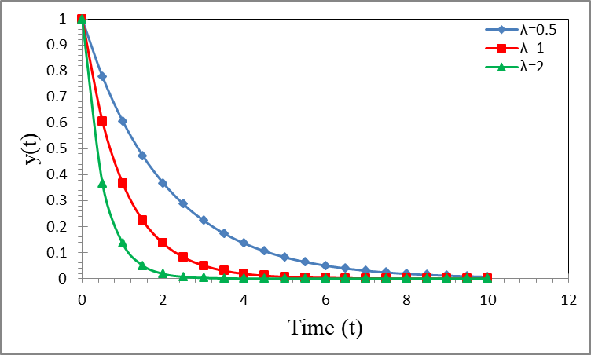
Figure 3: Effect of memory parameter λ on the system response
Figure 4 presents a direct comparison between the homogeneous and nonhomogeneous solutions of the proposed differential equation. This comparison highlights the impact of the external forcing term on the system dynamics. The homogeneous solution exhibits a smooth and monotonic exponential decay, governed solely by the system’s internal dynamics and memory effects. In contrast, the nonhomogeneous solution initially deviates from this behavior due to the presence of the forcing term $e^{-t}$. This results in a noticeable difference in the early-time response, where the nonhomogeneous solution may show a temporary shift before aligning with the decay trend. As time progresses, the influence of the forcing term diminishes, and both solutions converge toward zero. This indicates that the long-term behavior of the system is dominated by its inherent stability properties rather than the external input. The figure effectively demonstrates that while external forcing can significantly influence short-term dynamics, it does not alter the fundamental stability of the system. Additionally, the memory term ensures a smooth transition between the forced and natural responses, avoiding abrupt changes in the solution.
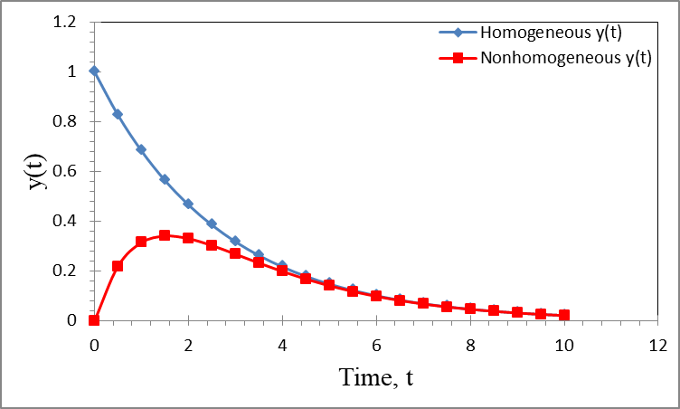
Figure 4: Comparison between homogeneous and nonhomogeneous solution responses
Table 4, Figure 3, and Figure 4 collectively emphasize the role of memory and external forcing in shaping system behavior. Table 4 provides a parametric understanding of memory effects, Figure 3 visualizes how these effects influence solution dynamics, and Figure 4 highlights the interaction between internal dynamics and external inputs. Together, these results confirm that the proposed differential equation offers a versatile and robust framework for modeling systems with both memory dependence and external influences.
CONCLUSION
This study introduced a novel memory-driven differential equation that incorporates a fading memory term through an exponential kernel, providing an extended framework beyond classical ordinary differential equations. By transforming the proposed integro-differential model into an equivalent system of first-order differential equations, analytical solutions were successfully derived for both homogeneous and nonhomogeneous cases. The results demonstrated that the inclusion of the memory term significantly enriches the dynamic behavior of the system. In particular, the model exhibits a dual-mode decay structure characterized by fast and slow components, which more accurately reflects real-world processes with temporal dependence. Stability analysis confirmed that the system remains asymptotically stable under the chosen parameters, as evidenced by negative eigenvalues and monotonic decay in the solution profiles. Furthermore, the effect of the memory parameter was systematically investigated, revealing its critical role in controlling the strength of historical influence on system behavior. Smaller values of the parameter resulted in prolonged memory effects and slower decay, while larger values led to faster convergence, mimicking classical dynamics. The inclusion of an external forcing term was also shown to influence transient behavior without altering long-term stability. The proposed model provides a flexible and robust mathematical tool for describing systems with memory-dependent dynamics. Its applicability extends to various fields, including physics, biology, and engineering, where delayed or history-dependent responses are essential. Future work may explore numerical methods, fractional extensions, and real-world applications of the model.

REFERENCES
- I. Podlubny, Fractional Differential Equations, Academic Press, 1999.
https://doi.org/10.1016/S0076-5392(99)80003-7
- A. A. Kilbas, H. M. Srivastava, and J. J. Trujillo, Theory and Applications of Fractional Differential Equations, Elsevier, 2006. https://doi.org/10.1016/S0304-0208(06)80001-0
- R. Garrappa and E. Kaslik, “On initial conditions for fractional delay differential equations,” 2020. https://doi.org/10.1016/j.cam.2020.112908
- G. Ali, K. Shah, and G. Ur Rahman, “Existence of solution to a class of fractional delay differential equation,” Arab J. Basic Appl. Sci., 2020. https://doi.org/10.1080/25765299.2020.1850621
- P. Zhu and Q. Xiang, “Oscillation criteria for fractional delay differential equations,” Adv. Differ. Equ., 2018. https://doi.org/10.1186/s13662-018-1813-6
- M. Develi and O. Duman, “Existence and stability of fractional delay differential equations,” J. Math., 2021. https://doi.org/10.1155/2021/814-2456-4
- H. M. Srivastava et al., “Fractional-order delay differential equations: existence and uniqueness,” Mathematics, 2024. https://doi.org/10.3390/math1411817
- N. I. Mahmudov, “Delayed Mittag-Leffler functions in fractional differential equations,” 2018. https://doi.org/10.1016/j.amc.2018.07.089
- V. E. Tarasov, “Differential equations with memory,” Appl. Math., 2011. https://doi.org/10.1016/j.physa.2011.07.020
- C. Briat, Linear Parameter-Varying and Time-Delay Systems, Springer, 2015.
https://doi.org/10.1007/978-3-662-44050-6
- T. Erneux, Applied Delay Differential Equations, Springer, 2009.
https://doi.org/10.1007/978-0-387-74372-5
- Y. Kuang, Delay Differential Equations with Applications, Academic Press, 1993.
https://doi.org/10.1016/C2013-0-11263-8
- R. Caponetto et al., Fractional Order Systems: Modeling and Control, World Scientific, 2010. https://doi.org/10.1142/7429
- K. S. Miller and B. Ross, An Introduction to Fractional Calculus, Wiley, 1993.
https://doi.org/10.1002/9781118032582
- K. B. Oldham and J. Spanier, The Fractional Calculus, Academic Press, 1974.
https://doi.org/10.1016/C2013-0-11637-6
- F. Mainardi, Fractional Calculus and Waves in Linear Viscoelasticity, Imperial College Press, 2010. https://doi.org/10.1142/p614
- S. Bhalekar and V. Daftardar-Gejji, “Fractional order systems with delay,” Nonlinear Dyn., 2010. https://doi.org/10.1007/s11071-010-9709-3
- J. Hale, Theory of Functional Differential Equations, Springer, 1977.
https://doi.org/10.1007/978-1-4612-9892-2
- A. A. Ali, M. RASHEED, Effect of changing magnetite percentage on structural and magnetic properties of cobalt ferrite prepared by the sol-gel method, Experimental and Theoretical NANOTECHNOLOGY, 10 (2026) 277–287. https://doi.org/10.56053/10.s.277.
- Khaleefah, M. RASHEED, Sol–gel-derived mullite nanoparticles: Structural and antibacterial insights, Experimental and Theoretical NANOTECHNOLOGY, 10 (2026) 289–300. https://doi.org/10.56053/10.s.289.
- Z. S. Ahmed, M. RASHEED, H. S. Ahmed, Optimizing NiO nanoparticle properties for antibacterial applications via temperature-driven structural modification, Experimental and Theoretical NANOTECHNOLOGY, 10 (2026) 329–342. https://doi.org/10.56053/10.s.329.
- Z. S. Ahmed, M. RASHEED, H. S. Ahmed, Enhancing α-Bi₂O₃ nanoparticle crystallinity and antibacterial functionality through controlled calcination, Experimental and Theoretical NANOTECHNOLOGY, 10 (2026) 343–356. https://doi.org/10.56053/10.s.343.
- A. I. A. Ali, M. RASHEED, Effect of sintering temperature on electrical and structural properties for spinel ferrites prepared by sol-gel method, Experimental and Theoretical NANOTECHNOLOGY, 10 (2026) 239–256. https://doi.org/10.56053/10.s.239.
- T. Rashid, M.M. Mokji, M. Rasheed, J. Mech. Behav. Mater. 34 (2025). https://doi.org/10.1515/jmbm-2025-0074
- M. Rasheed, M.N. Mohammedali, F.A. Sadiq, M.A. Sarhan, T. Saidani, J. Opt. 54 (2024) 3490-3504. https://doi.org/10.1007/s12596-024-01928-5
- S. Shihab, M. Rasheed, O. Alabdali, A.A. Abdulrahman, J. Phys.: Conf. Ser. 1879(2) (2021) 022120. https://doi.org/10.1088/1742-6596/1879/2/022120
- A. Zubaidi, L.M. Asaad, I. Alshalal, M. Rasheed, J. Mech. Behav. Mater. 32(1) (2023). https://doi.org/10.1515/jmbm-2022-0302.
- M. Ismael, T. Rashid, M.A. Sarhan, M. Rasheed, I.M. Sala, Eureka Phys. Eng. 4 (2023) 29–39. https://doi.org/10.21303/2461-4262.2023.002770
- H. K. Aity, E. Dhahri, M. Rasheed, Ceram. Int. (2024). https://doi.org/10.1016/j.ceramint.2024.10.324
- M. Mohammed, M. Rasheed, AIP Conf. Proc. 3321 (2025) 020026. https://doi.org/10.1063/5.0289719.

