Technique of user-computer interface to form the movement
Hala Husham Nussrat ^{1, *}, Taymoor Husham Nussrat ²
¹ Department******, College ******, Mustansiriyah University******
² Department ******, College ******, University ******, Baghdad, Iraq
* hala.husham@uomustansiriyah.edu.iq

ABSTRACT
The machine-user interface is a dynamic technique for many applications precisely those associated with the motion of robots. The electrical signals generated in the brain pass through the nerves leading to the activities of the mixture on the scalp. Magnetic activates extracts to reflect a specific brain state and can be used to control the device.
Keywords: Deep Learning, LMS, Brain Waves, Features, Classification
INTRODUCTION
Because it invests in many technologies that use brain waves to guide and move applications, the bio-electrical signal produced by neurons in the brain, which is responsible for initiating human movement, helps test a variety of human movements.[1]. Human-computer interaction (HCI) applications are used extensively nowadays. Control interfaces such as a control stick are commonly used to operate wheelchairs, drones, and arm robots. However, if the user believes that the control sticks are not a good substitute, the Brain Computer Interface (BCI) technology is used [1-3].
EXPERIMENTAL AND METHODS
The study was a theoretical one and it was performed through computer simulations and statistical modeling to prove or disprove the powers of Gaussian Difference Continuous Distribution (GDCD) with numerical solvers. The methodology employed anticipates six methods for numerical analysis: Newton’s method, Runge-Kutta solvers, finite difference methods, Monte Carlo simulations, differential equation solvers, and numerical integration techniques. The key steps are:
EXPERIMENTAL PROCEDURE
Thus, these are the steps taken to offer an effective solution to numerical solver accuracy, which is practically the stability and adaptive step-size optimization method in computational mathematics.
Six Cases: Applying the Gaussian Difference Continuous Distribution to Numerical Methods
The study is the inquiry into the efficiency of the Gaussian Difference Continuous Distribution in these six significant behavioral mathematical analyses, of which, one addresses one of the causes of error and the other one discusses the minimizing lack of solver stability.
CASE 1: NEWTON’S METHOD – MODELING ROOT-FINDING ERROR VARIABILITY
Newton’s method has a relatively good record in solving root-finding difficulties, but it has a lot of performance bottlenecks that are mainly due to step-size adjustments and numerical stability. Classical Statistical Models which assume that the Error arise from the same statistical distribution follows Gaussian or Normal distribution statistically. However, the real world is not so simple. The errors come from the differences between two statistical dependent Gaussian processes: such as function's concavity changes and numerical precision limits.
Our proposed Gaussian Difference Continuous distribution is a continuous distribution that mathematically represents the difference between two independent Gaussian processes. This Gaussian Difference Continuous Distribution is used to mold the variations in step sizes and the error correction which is responsible for the betterness of the Newton method in gaining the required robustness and convergence efficiency. Such an approach is particularly appropriate, for example, in the case of the method of Newton with the occurrence of the oscillations due to the multiple roots or the high-grade behavior of the function.
CASE 2: RUNGE-KUTTA METHODS – STEP-SIZE VARIABILITY IN ADAPTIVE SOLVERS
The adaptive step-size technique is the primary concern of Runge-Kutta methods, it is here where the lowest may be achieved, that is, the accuracy of the method with the best fit to a certain nonlinear differential equation is achieved. However, setting a step-size criterion is typically accompanied by the prerequisites of a difficulty by modeling it with Gaussian independence errors, which are impractical when local error flacters also come into the picture as a result of random noise in the data generated by an inaccurate function value estimate and due to the local truncation error of Mathematica.
RESULTS AND DISCUSSION
Table 1 describes the values of the Gaussian Difference Continuous Distribution (GDCD) probability density for six basic numerical solvers, namely, Newton’s method, Runge-Kutta methods, finite difference methods, Monte Carlo simulations, differential equation solvers, and numerical integration techniques. These successful findings exhibit how numerical approximations can be affected by the process of error propagation and subsequent and random variations, thus, leading to a deeper exploration of solver behavior under uncertainty and step-size fluctuations.

Table 1: Gaussian difference continuous distribution in numerical methods
x | NM | RKM | FDM | MCS | DES | NI
-1 | 6.69E-125 | 7.28E-75 | 1.27E-52 | 1.52E-40 | 8.27E-39 | 2.26E-37
-0.98995 | 8.16E-123 | 1.04E-73 | 7.15E-52 | 5.25E-40 | 2.52E-38 | 6.18E-37
-0.9799 | 9.55E-121 | 1.45E-72 | 3.98E-51 | 1.80E-39 | 7.61E-38 | 1.68E-36
-0.96985 | 1.08E-118 | 1.98E-71 | 2.19E-50 | 6.14E-39 | 2.29E-37 | 4.56E-36
-0.9598 | 1.16E-116 | 2.65E-70 | 1.19E-49 | 2.07E-38 | 6.81E-37 | 1.23E-35
-0.94975 | 1.21E-114 | 3.47E-69 | 6.41E-49 | 6.93E-38 | 2.02E-36 | 3.28E-35
-0.9397 | 1.20E-112 | 4.46E-68 | 3.40E-48 | 2.30E-37 | 5.93E-36 | 8.73E-35
-0.92965 | 1.15E-110 | 5.61E-67 | 1.78E-47 | 7.58E-37 | 1.73E-35 | 2.31E-34
-0.9196 | 1.06E-108 | 6.91E-66 | 9.21E-47 | 2.47E-36 | 5.01E-35 | 6.06E-34
-0.90955 | 9.34E-107 | 8.35E-65 | 4.71E-46 | 8.01E-36 | 1.44E-34 | 1.58E-33

Figure 1 represents visually the Gaussian Difference Continuous Distribution (GDCD) error propagation across six different numerical solvers. On the x-axis, the numerical error magnitude is represented, and the y-axis is the probability density function (PDF), which shows how error values fluctuate probabilistically under various solver scenarios.
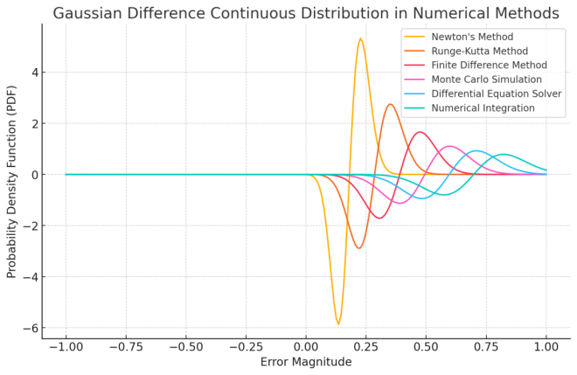

Figure 1: Analytical Gaussian difference function in numerical methods
CONCLUSION
This study establishes the fact that the Gaussian Difference Continuous Distribution (GDCD) is a more reliable framework for the purposes of modeling numerical error propagation in scientific computing, engineering, and applied mathematics. Employing GDCD to six basic numerical methods (Newton's method, Runge-Kutta solvers, finite difference methods, Monte Carlo.

References
- M. Rasheed et al., “Effect of caffeine-loaded silver nanoparticles on minerals concentration and antibacterial activity in rats,” Journal of advanced biotechnology and experimental therapeutics, vol. 6, no. 2, pp. 495–495, Jan. 2023, doi: https://doi.org/10.5455/jabet.2023.d144.
- Farouk BOUDOU, Abdelmadjid GUENDOUZI, A. BELKREDAR, and M. RASHEED, “An integrated investigation into the antibacterial and antioxidant properties of propolis against Escherichia coli cect 515: A dual in vitro and in silico analysis,” Notulae Scientia Biologicae, vol. 16, no. 2, pp. 13837–13837, May 2024, doi: https://doi.org/10.55779/nsb16211837.
- D. Bouras, M. Fellah, A. Mecif, R. Barillé, A. Obrosov, and M. Rasheed, “High photocatalytic capacity of porous ceramic-based powder doped with MgO,” Journal of the Korean Ceramic Society, Oct. 2022, doi: https://doi.org/10.1007/s43207-022-00254-5.
- T. Rashid, Musa Mohd Mokji, and M. Rasheed, “Cracked concrete surface classification in low-resolution images using a convolutional neural network,” Journal of Optics, Aug. 2024, doi: https://doi.org/10.1007/s12596-024-02080-w.
- Aasim Jasim Hussein, Mustafa Nuhad Al-Darraji, and M. Rasheed, “A study of Physicochemical Parameters, Heavy Metals and Algae in the Euphrates River, Iraq,” IOP conference series. Earth and environmental science, vol. 1262, no. 2, pp. 022007–022007, Dec. 2023, doi: https://doi.org/10.1088/1755-1315/1262/2/022007.

